Logistic regression:

1)
X = pima[:, [1,3]]
Misclassified samples: 63
Accuracy: 0.73
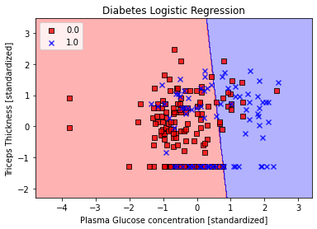
2) Using 20% data for test set
X_train, X_test, y_train, y_test = train_test_split(X,y, test_size=0.2,
random_state=1, stratify=y)
Misclassified samples: 40
Accuracy: 0.74

3)
lr = LogisticRegression(C=100.0, random_state=1)
c is a hyper parameter which controls over fitting. More the value of c more will be the over fitting.
If we change the value of c to 10 or 100 there will be slight variation in the weights.
When c=10 [[1.20068073 0.06587778]]
When c=100 [[1.20211922 0.06590301]]
When c=1000 [[1.20226335 0.06590553]]

4)
Using all the 8 features in the input x:
X = pima[:, :8]
Misclassified samples: 33
Accuracy: 0.79
If we do not change the plotting code we will end up getting an error message stating “ValueError: X has 2 features per sample; expecting 8”

KNN:
1)
Using 10 nearest neighbours to classify the data increases the accuracy.
knn = KNeighborsClassifier(n_neighbors=10, p=2, metric='minkowski')
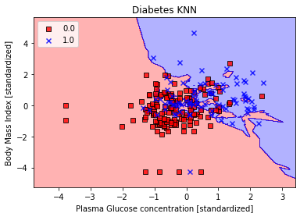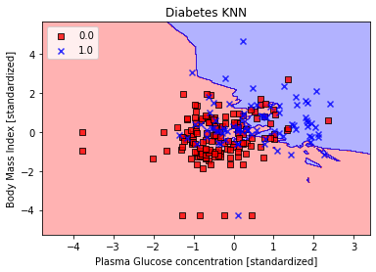
when n_neighbors=5 when n_neighbors=10
Misclassified samples: 66 Misclassified samples: 62
Accuracy: 0.71 Accuracy:0.73

2)
Minkowski metric is a metric in a normed vector space used to find distance similarity of 2 or more vectors.
If we change the metric although accuracy remains same the number of misclassified samples changes,the resulting plots will also change .
Ex:
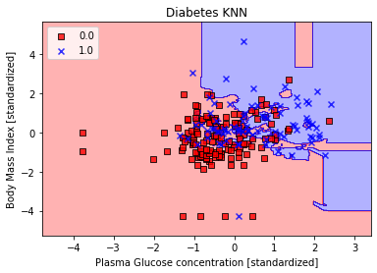
metric='manhattan'

metric='euclidean'

Classify the IRIS flower dataset using Logistic Regression
1)
Logistic regression is used to describe data and to explain the relationship between one dependent binary variable and one or more nominal, ordinal, interval or ratio-level independent variables.
Logistic regression is SUPERVISED classification algorithm.

2)
print('Labels counts in y:', np.bincount(y))

This method is used to count the frequency of each element in a NumPy array of non-negative integers. It stores the count of the element as its index in the frequency array or bin and print function prints this numpy array.

3)
[1.52213484e-12, 3.85303417e-04, 9.99614697e-01],
[9.93560717e-01, 6.43928295e-03, 1.14112016e-15],
[9.98655228e-01, 1.34477208e-03, 1.76178271e-17],
[3.79431985e-06, 9.04401285e-01, 9.55949212e-02],
[5.22212406e-05, 9.94209099e-01, 5.73867966e-03],
[3.32077165e-04, 9.99436958e-01, 2.30964664e-04],
[8.58735890e-11, 1.51543901e-03, 9.98484561e-01],
[1.84300715e-05, 9.77595601e-01, 2.23859686e-02],
[1.56619564e-09, 1.49383130e-02, 9.85061685e-01],
[9.97832874e-01, 2.16712646e-03, 3.30341025e-17]]

sum of probabilities in each row is 1.0
[1., 1., 1., 1., 1., 1., 1., 1., 1., 1.]

4)
for c in np.arange(-5, 5):
here np.arange(-5,5) creates a numeric sequence between -5 to 5 and variable c iterates through all these values.
Later in the code this value is raised to the power of C(hyper parameter) (C**c ) in order to get a proper fit because curve fit depends on hyper parameter,greater the hyper parameter more will be over-fitting.

